CLASS PROJECT
Project 1: The One-Minute Video

Video content tends to perform the best on Facebook, as stated in this chapter. Dennis Yu and Logan Young of BlitzMetrics travel the world teaching businesses and individuals the principles presented in “4 Components of the Minute Video.”

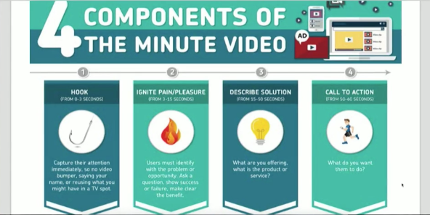

Analyze the image above, “4 Components of the Minute Video,” and then watch Young’s live example video from a recent social media marketing conference.
- Record your own one-minute video. It can be on any topic so long as the video follows the four components of the one-minute video as outlined above.
- You can record their videos via camera or phone (doesn’t have to be high-production quality).
Grading:
Make sure your videos include the four components of the one-minute video as presented as part of this assignment.

